VBugs Chapter 2 Worksheet

|  |
| --- |
| **Name:** |
| **Year Level: SOLUTIONS** |

**Part 1**

Question 1: What is the difference between a sprite and an image?

A sprite is a small graphic that can be moved independently around the screen, producing animated effects.

Exercise 1: *Creating a sprite*

1. Declare the variable “bug” which is a Sprite. Write the code you used to achieve this in the area below:

|  |
| --- |
| Answer:  Dim bug As Sprite  …  'Load Resources  LoadResources()      'Game Loop  … |

1. Write the code which enables you to create the sprite in the area below:

|  |
| --- |
| Answer:  bug = Graphics.CreateSprite(GameImage("sprite"))  …  'Load Resources  LoadResources()  *?Line from last question?* |

1. Draw the sprite on the screen. Write the code that enables you to do this in the area below:

|  |
| --- |
| Answer:  Graphics.DrawSprite(bug)  …  …  'Clears the Screen to Black  SwinGame.Graphics.ClearScreen(Color.White)      'Refreshes the Screen and Processes Input Events  … |

1. Put Graphics.FreeSprite(variableName) at the end of your program. Write the code that you entered to your program in the area below.

|  |
| --- |
| Answer:  Graphics.FreeSprite(bug)  …  …  'Free Resources and Close Audio, to end the program. FreeResources()      … |

**Part 2**

Exercise 1: *Making the sprite to move*

1. Assign Movement.X of your sprite to 0.5 and put this code before the start of the game loop. Write the code that enables you to do this in the area below:

|  |
| --- |
| Answer:  bug.Movement.X = 0.5  …  …  'Load Resources  LoadResources()      'Game Loop  … |

1. In order to see how our sprite moves, it needs to be updated within the loop. Write the code that enables you to do this in the area below:

|  |
| --- |
| Answer:  Graphics.UpdateSprite(bug)  …  …  'Game Loop  Do    'Refreshes the Screen and Processes Input Events  Core.RefreshScreen()  … |

**Part 3**

Question 1: Write the pseudocode for an “IF Statement” where if x is 200 it says “Perfect score” otherwise it divides x by 200 and displays the result to the screen.

|  |
| --- |
| Answer:  If x = 200 then  Write “Perfect Score”  Else  Divide x by 200  Write x  End If  …  …                … |

Question 2: Write the pseudocode for an “IF Statement” where if x is above 40 it says “Very Hot” if it is above 30 it says “Hot” otherwise it says “Mild”.

|  |
| --- |
| Answer:  If x > 40 then  Write “Very Hot”  End If  If x > 30 and x < 41  Write “Hot”  End if  If x < 31  Write “Mild”  End If  …  …                  … |

Exercise 1: *Stopping the Sprite from moving off the right edge of the screen.*

1. Add the following code to the Game Loop after the line containing Graphics.UpdateSprite(bug) then below describe what each line is doing:

|  |
| --- |
| If variableName.X + variableName.Width >= Core.ScreenWidth Then  variableName.Movement.X = -0.5  End If |

|  |
| --- |
| It adds the Width of the Bug to its X position in order to get the locoation of the right hand side of the bug and tests to see if this point is greater than or equal to the screen width.  This line executes if the bug has reached the right hand side of the screen and it basically reverses the X (horizontal) movement of the bug at a speed of 0.5.  If variableName.X + variableName.Width >= Core.ScreenWidth Then  The purpose of this line is:        variableName.Movement.X = -0.5  The purpose of this line is:        End If |

1. Press the "StartDebugging" button at the top of the screen (looks like a green arrow arrow.jpg, F5 works too) to see what it does.

**Part 4**

Exercise 1: *Stopping the Sprite from moving off the left edge of the screen*

1. Add the code to the Game Loop that will test if the bug’s X position is less than or equal to 0 and if it is set its movement to positive 0.5. Place this code after the code from the previous exercise, copy the code below:

|  |
| --- |
| If bug.X <= 0 Then  bug.Movement.X = 0.5  End If  Answer:  …          … |

1. Press the "StartDebugging" button at the top of the screen (looks like a green arrow arrow.jpg, F5 works too) to test the code then close the window.

Exercise 2: *Changing the movement direction.*

1. Assign Movement.Y of the Sprite to 0.5, this can be done in the same way as shown in part 1 > exercise 1. Write the code that enables you to do this in the area below:

|  |
| --- |
| Answer:  bug.Movement.Y = 0.5  …  bug.Movement.X = 0.5    'Game Loop  Do  … |

1. Write the code which will stop the Sprite from moving off the top edge of the screen. Write the code that enables you to do this in the area below:

|  |
| --- |
| Answer:  If bug.Y <= 0 Then  bug.Movement.Y = 0.5  End If  Graphics.DrawSprite(bug)  Graphics.UpdateSprite(bug)          'Refreshes the Screen and Processes Input Events |

1. Write the code which will stop the Sprite from moving off the bottom edge of the screen. Write the code that enables you to do this in the area below (hint: you will have to think about Height in this case instead of Width):

|  |
| --- |
| Answer:  If bug.Y + bug.Height >= Core.ScreenHeight Then  bug.Movement.Y = -0.5  End If  Graphics.DrawSprite(bug)  Graphics.UpdateSprite(bug)        If bug.Y <= 0 Then  bug.Movement.Y = 0.5  End If  'Refreshes the Screen and Processes Input Events |

Question 1: Understanding Direction

1. *A bug travelling with and X movement of 2 and a Y Movement of 2 would go in which direction (draw an arrow from the bug below indicating the direction it will go when the program in initiated).*

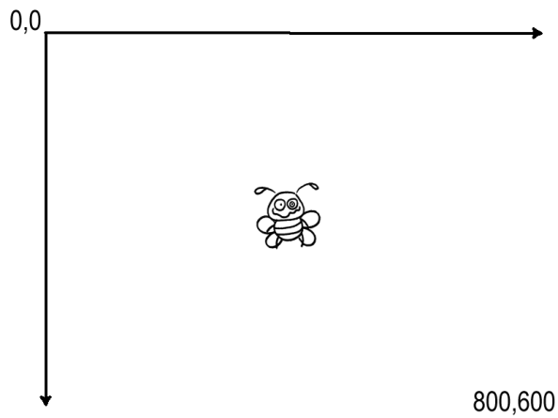

1. *A bug travelling with and X movement of 0 and a Y Movement of -2 would go in which direction.*

**

1. *A bug travelling with and X movement of -0.5 and a Y Movement of 1 would go in which direction.*

**

1. *A bug travelling with and X movement of -2 and a Y Movement of -1.5 would go in which direction.*

**

1. *A bug travelling with and X movement of -1 and a Y Movement of -2 would go in which direction.*

**

**Part 5:**

Exercise 1: *Two Bugs*

Add a second Sprite to your program, follow the same steps you did for the first bug to achieve this. You will need to give your second bug a different name in the code (e.g. bug1).

…

LoadResources()

Dim bug1 As Sprite

bug1 = Graphics.CreateSprite(GameImage("sprite"))

bug1.Movement.X = -0.7

bug1.Movement.Y = 0.7

'Game Loop

Do

'Clears the Screen to Black

SwinGame.Graphics.ClearScreen(Color.White)

Graphics.DrawSprite(bug1)

Graphics.UpdateSprite(bug1)

If bug1.X + bug1.Width >= Core.ScreenWidth Then

bug1.Movement.X = -0.5

End If

If bug1.X <= 0 Then

bug1.Movement.X = 0.5

End If

If bug1.Y + bug1.Height >= Core.ScreenHeight Then

bug1.Movement.Y = -0.5

End If

If bug1.Y <= 0 Then

bug1.Movement.Y = 0.5

End If

'Refreshes the Screen and Processes Input Events

Core.RefreshScreen()

Core.ProcessEvents()

Loop Until SwinGame.Core.WindowCloseRequested() = True

'Free Resources and Close Audio, to end the program

Graphics.FreeSprite(bug1)

|  |
| --- |
| Answer: |